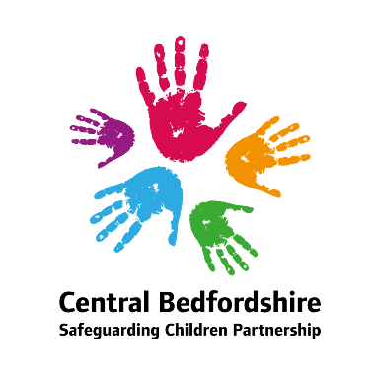**Central Bedfordshire Safeguarding Children Partnership**

**Annual Report 2024-25**

**Partnership Foreword:**

Welcome to this year’s Central Bedfordshire Safeguarding Children Partnership’s Annual Report.

This report is a testament to the dedication and commitment of practitioners across our multi-agency partnership, and it reflects the genuine collaboration and shared purpose demonstrated by our partners at every level. The effort that has gone into producing this report mirrors the hard work and passion that underpin our safeguarding practice throughout the year.

Over the past twelve months, we have much to celebrate. Notable achievements include a significant increase in our quality assurance and audit activity, the successful development of our multi-agency chronologies pilot, and the initial implementation of our new joint multi-agency supervisions. These milestones highlight our ongoing drive for innovation and improvement in safeguarding practice.

However, our journey has also been one of learning and reflection. Through rapid reviews and safeguarding practice reviews, we have identified important lessons that will shape our future work. Embedding this learning across the partnership remains a key priority, ensuring that we continually strengthen our approach and adapt to emerging challenges.

Looking ahead, our focus must remain on working together to safeguard children and young people. As a partnership, we are committed to developing robust ways to measure the impact and effectiveness of our work, so that we can be confident the Partnership is making a real and lasting difference to the lives of children and families in Central Bedfordshire

**Amana Gordon, Director of Children and Families, Central Bedfordshire Council**

**Assistant Chief Constable John Murphy, Bedfordshire Police**

**Sarah Stanley, Chief Nurse, BLMK ICB**

**Independent Scrutineer Foreword:**

I am pleased to provide this foreword as the newly appointed Independent Scrutineer for the Central Bedfordshire Safeguarding Children Partnership (CBSCP). Since taking up this role, I have been impressed by the commitment, professionalism, and collaborative ethos that characterise the Partnership’s work. This annual report reflects both the challenges we face, and the progress made in safeguarding children and young people, while also highlighting the opportunities ahead to strengthen our collective impact.

The role of Independent Scrutineer, as outlined in *Working Together* 2023, is to provide rigorous, evidence-based challenge and assurance across strategic and operational levels. My focus is on driving continuous improvement, ensuring statutory duties are fulfilled, and embedding learning from both local and national reviews. Central to this is amplifying the voice and lived experience of children, young people, and their families—ensuring their perspectives inform policy, practice, and strategic direction., as well as ensuring that the voice and experience of practice is heard and is reflected in practice, policy, and strategy development. The safeguarding landscape is increasingly complex, shaped by societal and cost pressures, emerging risks, and evolving practice. In Central Bedfordshire, the Partnership has responded with agility and purpose. However, scrutiny must remain sharp and forward-looking to ensure every child is seen, heard, and protected.

**Key Themes and Observations**

Neglect remains a persistent concern. The ongoing review of early help pathways and thresholds is a positive step, and scrutiny will focus on whether these changes lead to timely, proportionate, and effective intervention—particularly in supporting emotional wellbeing and preventing escalation into statutory services.

Contextual safeguarding, including peer-on-peer exploitation and online harm, continues to demand attention. Police-led disruption and school-based interventions are commendable, but a more strategic, joined-up approach is needed to address the increasing complexity of online risks.

Mental health and emotional wellbeing are central to safeguarding practice. Integrated models involving CAMHS and Early Help have received encouraging feedback, and scrutiny will assess their effectiveness in meeting the growing complexity of family needs, often exacerbated by socio-economic pressures.

Child Sexual Abuse (CSA) remains a priority. The pan-Bedfordshire CSA Steering Group provides good multi-agency leadership, and the rollout of trauma-informed training and CSA pathway tools are examples of good practice. The forthcoming Joint Targeted Area Inspection (JTAI) on CSA in the family environment will be a key moment for reflection and learning.

The voice of the child must be more consistently embedded in our safeguarding system. Plans to establish focus groups with children and parents are a welcome development. Scrutiny will ensure that their lived experiences inform service design and delivery, making practice more responsive and respectful.

The Partnership culture is collaborative, and improvement focused. However, the impact of its work must be more clearly evidenced. The review of Multi-Agency Safeguarding Arrangements (MASA) presents an opportunity to sharpen strategic focus and ensure structures are fit for purpose.

Embedding learning and demonstrating its impact remains an area for development. Strengthening the learning framework will be essential to ensure that insights from audits, reviews, and frontline feedback lead to tangible improvements. Additionally, scrutiny will assess how equity, equality, diversity, and inclusion (EEDI) are being addressed across safeguarding practice.

Looking outward to national learning, including the work of the National Child Safeguarding Practice Review Panel, will enrich our local approach. A stronger focus on digital safeguarding is also essential, given the centrality of online life to children and young people.

**Priorities for Independent Scrutiny**

* In line with statutory guidance, my priorities for the coming year include:
* Establishing practitioner and parent/child focus groups to capture lived experience and inform scrutiny.
* Conducting thematic deep dives into areas such as strategy meetings, police powers out of hours, and non-accidental injury (NAI) cases.
* Completing a review of MASA arrangements and supporting implementation while scrutinising progress.
* Enhancing scrutiny of early help effectiveness, particularly in relation to neglect and emotional wellbeing.
* Evaluating the impact of learning from Child Safeguarding Practice Reviews (CSPRs) and Rapid Reviews (RRs).
* Assessing the effectiveness of multi-agency safeguarding training, quality assurance mechanisms, and strategic leadership.

Scrutiny will be undertaken through a range of methods including interviews, focus groups, data analysis, and peer review, always ensuring that the voice and experience of children and families are central.

Safeguarding is a shared endeavour that demands courage, curiosity, collaboration, and compassion. I look forward to working alongside all partners to ensure our collective efforts make a meaningful and measurable difference in the lives of children and families in Central Bedfordshire.

**Jon Brown  
Independent Scrutineer  
Central Bedfordshire Safeguarding Children Partnership**

**Introduction to Central Bedfordshire:**

Central Bedfordshire has a growing population of 307,200. It is largely rural by area, with more than a third of the population living in rural areas and the rest in a number of market towns. The area is generally prosperous, with above average levels of employment, however there are pockets of deprivation and greater need.

Between 2013-2023, Central Bedfordshire’s population rose by 16.7%, this is above the average rate for England (7.0%) and among the fastest-growing areas in the country. By age group, over the same period, there was a 17.7% increase in children aged 0-17, a 13.4% increase in adults aged 18-64 and a 27.1% increase in older people aged 65+.

Central Bedfordshire’s [Census 2021 factsheet](https://www.centralbedfordshire.gov.uk/info/27/about_your_council/180/statistics_and_census_information/5) provides information on the ethnicity of residents; White British (83.5%), White- Other (5.3%), Indian (1.6%), Black African (1.3%) White Irish (1.2%), and White/ Black Caribbean (1.1%). Over 95% of pupils of compulsory school age speak English as a first language. However, more than 60 different first languages are recorded among the remaining children.

In 2024, the crime rate in Central Bedfordshire was lower than the average across similar areas. *(Source:* [*Police UK*](https://www.police.uk/pu/your-area/bedfordshire-police/performance/compare-your-area/?tc=CB1)*).* Life expectancy and overall health are both slightly better than the national average, and children are less likely to be obese. *(Source:* [*Map | Local Insight*](https://centralbedfordshire.localinsight.org/#/map)*, May 2025)*

**Children and Young People:**

**Children in low-income (relative) households by local authority:**

|  |  |  |  |  |  |
| --- | --- | --- | --- | --- | --- |
| **LAs** | **2022/23** | **2023/24** | **2023 MYE population aged 0-15** | **2022/23 rate** | **2023/24 rate** |
| Central Bedfordshire | 8,778 | 9,374 | 60,987 | 14% | 15% |
|  |  |  |  |  |  |
| Luton | 22,569 | 23,248 | 53,810 | 42% | 43% |
| Buckinghamshire | 17,048 | 17,751 | 113,211 | 15% | 16% |
| Bedford | 8,777 | 9,323 | 38,425 | 23% | 24% |
| Southend-on-Sea | 7,887 | 8,425 | 34,536 | 23% | 24% |
| Huntingdonshire | 5,453 | 5,769 | 33,863 | 16% | 17% |
| Dacorum | 4,669 | 4,939 | 31,955 | 15% | 15% |
| North Hertfordshire | 3,902 | 3,853 | 25,699 | 15% | 15% |
| South Cambridgeshire | 3,806 | 3,899 | 33,422 | 11% | 12% |
| St Albans | 3,362 | 3,466 | 32,015 | 11% | 11% |
| Milton Keynes | 13,866 | 14,816 | 64,985 | 21% | 23% |

**Sources:** Department for Work and Pensions, Children in low-income families (relative) and Office for National Statistics, Mid-Year Estimates of Population 2023. Note that the rates are a local calculation based on these published figures.

**Education Information:**

|  |  |
| --- | --- |
| **Education Information January 2025 census** | |
| No. pupils in Central Bedfordshire schools | 49415 |
| % of minority ethnic background | 25.5% (England 38.0%) |
| No. of pupils eligible for Free School Meals (FSM) | 14.0% (England 25.7%) |
| No. of pupils receiving Free School Meals (FSM) | 6914 |
| No. of children with SEN Support | 5665 |
| No. of children with Education Health Care Plan (EHCP) | 3068 |

**Vulnerable Children:**

The majority of children and young people in Central Bedfordshire enjoy safe and healthy lives within their family networks and communities, however, there are a proportion of vulnerable children who are at risk of poorer health and well-being outcomes. This section of the Annual Report sets out those categories of children and young people in Central Bedfordshire who have been identified by the local authority and other agencies as in need of help or protection to promote their welfare.

**Children’s Services Integrated Front Door:**

The Integrated Front Door Team is the front door for anyone seeking information and/ or services for children, young people, and families, or to make a safeguarding referral. The Multi-Agency Safeguarding Hub (MASH) is based here. During 2024/25 the team received 17,256 enquiries, and 2,286 referrals into Children’s Social Care. (compared to 17,247 and 2,100 last year).

**Early Help:**

Central Bedfordshire’s Early Help Locality Teams are integral to the delivery of the Children and Young People’s Plan and the Central Bedfordshire multi-agency partnership early help offer. Early Help has been at the forefront of Children’s Services Transformation and is a responsive locality focused service to support children and families who without support are likely to require statutory social care intervention with the aim of reducing demand on Children’s Services. The two service areas work together to develop a positive partnership between professionals and families that empowers families of children and young people and builds resilience and wellbeing in individuals, families, and communities.

Central Bedfordshire's Early Help Offer identifies the need for help for children and families as soon as problems emerge, or when there is a strong likelihood they will emerge in the future, offering ‘the right help at the right time’. The Early Help Offer includes universal and targeted services designed to reduce or prevent specific problems from escalating or becoming entrenched.

Early Help support can be grouped into 3 main areas:

1. Universal and targeted support through community-based services.
2. Multi-agency support which is co-ordinated by a range of professionals.
3. Targeted Early Help assessment and support for higher levels of identified need e.g. Early Help Plus.

During 2024/25 there were 1,059 Early Help Assessments (EHA’s) completed by Children’s Services (compared to 724 last year) with a further 315 EHA’s being completed by partners in the community (compared to 339 last year)

At the end of 2024/25 there were 691 children who were a Child in Need compared to 762 at the end of last year.

**Children with a Child Protection Plan:**

Children who have a child protection plan are considered to be in need of protection from either neglect, physical, sexual, or emotional abuse or a combination of one or more of these. The child protection plan sets out the main areas of concern, what action will be taken to reduce these concerns and by whom. The plan will also set out how we will know when progress is being made.

At the end of 2024/25 there were 177 children with a Child Protection Plan in Central Bedfordshire (compared to 224 at the end of previous year)

**Children in Care:**

Children in care are those looked after by the local authority. Only after exploring every possibility of protecting a child at home will the local authority seek a parent’s consent or a court’s decision to move a child away from his or her family. Such decisions, whilst very difficult, are made in the best interests of the child.

At the end of 2024/25 there were 338 Looked After Children in Central Bedfordshire (compared to 384 at the end of the previous year).

**The Central Bedfordshire Multi-Agency Safeguarding Arrangements:**

The Central Bedfordshire Multi-Agency Safeguarding Arrangements cover the Local Authority area of Central Bedfordshire. The three Safeguarding Partners are Central Bedfordshire Council, Bedfordshire Clinical Commissioning Group and Bedfordshire Police.

Central Bedfordshire Safeguarding Children Partnership works closely with neighbouring Partnerships in Bedford Borough and Luton. As such, our structure also includes a number of Pan Bedfordshire groups. The Independent Scrutiny for our partnership during 2024/25 was provided by an Independent Scrutineer, Alan Caton.

**MASA Structure:**

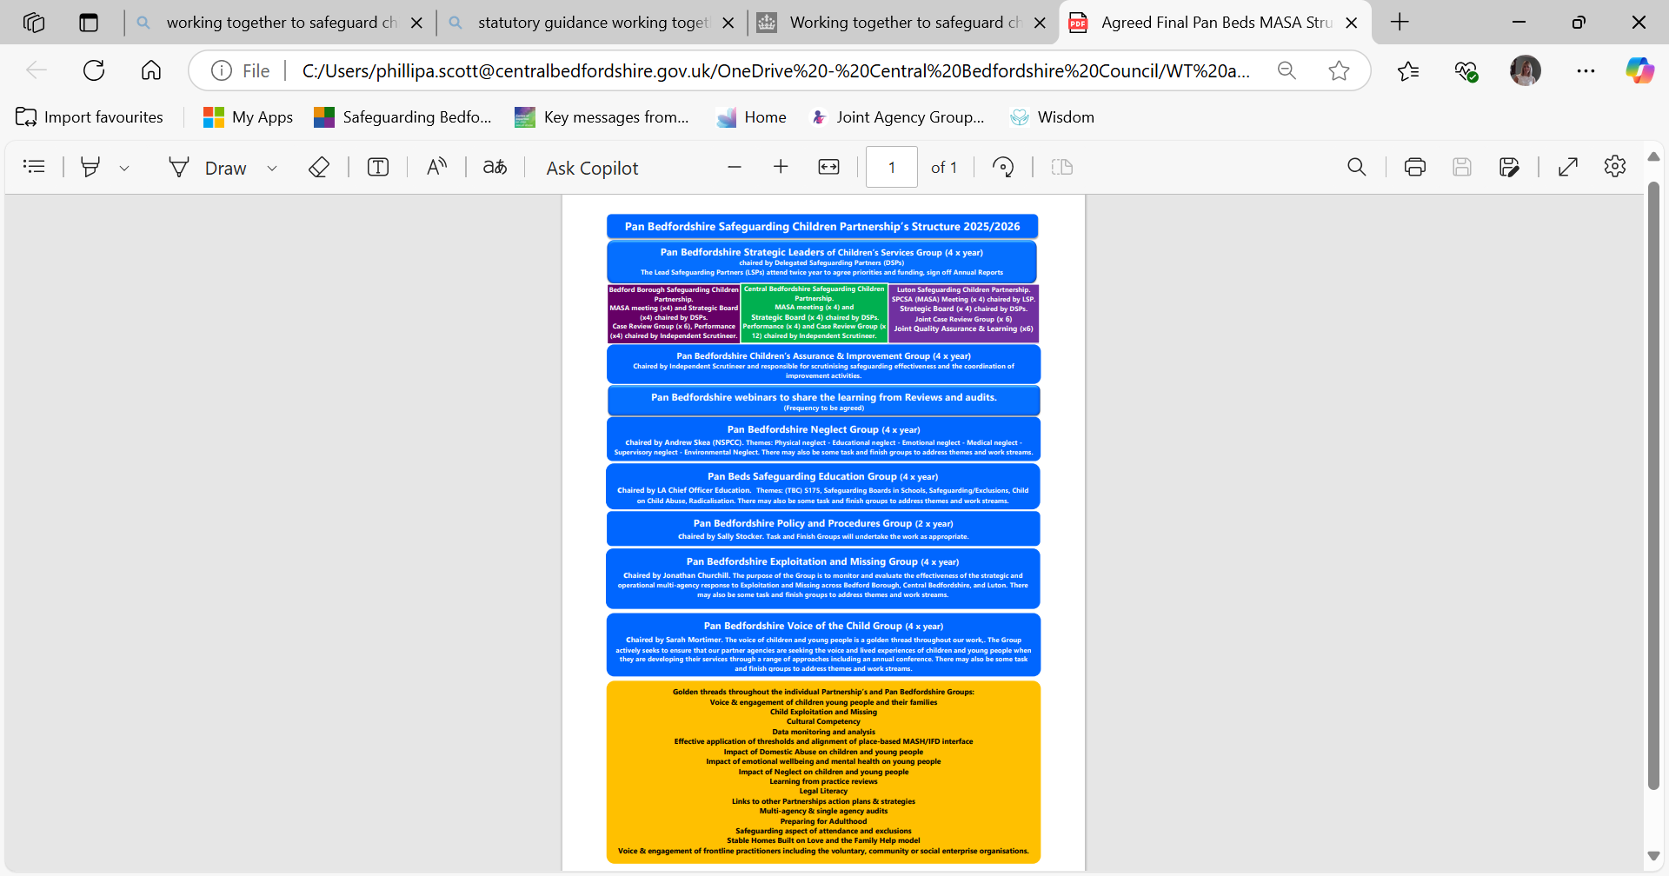

**The Partnership Priorities for 2024/25:**

The Partnership held its development session for 2024-25 on the 13th May 2024. The discussions highlighted some positive work that had taken place over the previous year, including the Partnership’s Voice of the Child work, including its young people’s conference, its joined up working to better understand thresholds and its work to strengthen the MASH arrangements which has been an on-going piece of work.

It was noted that partners had continued to work together to tackle the issue of neglect and better embed the use of tools such as the graded care profile, however some case reviews had highlighted there was still further work to be done.

It was agreed that other key areas of work/focus moving forward was to review our response and structures in relation to exploitation, develop our joined-up response to child sexual abuse and to continue developing our quality assurance and analytical work.

As the Partnership moved forward with implementing the changes required for Working Together 2023, it moved forward with the vison of ‘Strong Leadership, Strong Partnership’.

**2024/25 Priorities:**

* Establishing Strong Leadership with our Partners
* Effectively learning from our Case Reviews
* Back to basics training
* Effective Assessments

**Key Areas of Work:**

* Neglect
* Child Sexual Abuse
* Exploitation
* Mental Health and Wellbeing

**Golden Threads:**

* Communications – how do we talk about safeguarding.
* Information Sharing
* Voice of the Child
* Transitions
* Early Help
* Good Quality Assessments
* Learning from our Case Reviews

**The work of the partnership including multi-agency audits and quality assurance work:**

Over the past 14 months the Partnership has accelerated the amount of multiagency assurance work that has taken place. To strengthen this position further as part of our review of our Multi-Agency Safeguarding Arrangements, we have formed a new multi-agency Pan Beds Assurance and Improvement Group to ensure the impact from assurance work is evidenced, the learning progressed and any future assurance work that is required, is scheduled.

**CBSCP has undertaken the following assurance activities:**

* Pan Bedfordshire CIN Neglect Audit – October 2023
* Serious Youth Violence Audit – February 2024
* CBSCP Re-Referrals Audit – May 2024
* Pan Bedfordshire Child to Parent Abuse Audit – October 2024
* Pan Bedfordshire Child Sexual Abuse – NSPCC Snapshot – October 2024
* Pan Bedfordshire Voice of the Child and Was Not Brought Assurance Reports – June – November 2024
* Central Bedfordshire Multi-Agency Neglect Audit – February 2025

**Neglect:**

The Pan Bedfordshire **Neglect Strategy Annual Delivery Plan** was refreshed in May 2024 and contained the following priorities:

* **Priority 1:** Strategic commitment across all agencies to understand, prevent and reduce the impact of neglect Pan Bedfordshire.
* **Priority 2:** Better understanding of Neglect through a dataset, learning from audits and through research.
* **Priority 3:** To re-launch and embed the Graded Care Profile (GCP2) Pan Bedfordshire.
* **Priority 4:** To re-launch and embed the Neglect Screening Tool.
* **Priority 5:** Equip our safeguarding workforce to respond to training and development needs - Neglect.
* **Priority 6:** To continue to raise awareness of Neglect.

**Work of the Neglect Sub-Group including follow-up from 2023 CIN Neglect Audit:**

In October 2023 the Neglect Sub-Group carried out a Pan Bedfordshire Neglect/Child in Need Audit.

The audit highlighted several areas of good practice including that there was a wide range of multi-agency partners involved in supporting cases including schools and housing teams, there was evidence of appropriate interventions being put in place, overall good information sharing, some examples of the escalation process being used when needed and, in some cases, the GCP2 was used.

There were also some areas for improvement that were identified, these included, although partners were working with families and lots of interventions were put in place some families had been known to services for a significant period of time and there was no or little evidence of sustained change, the GCP2 was not being used as standard practice, some cases hadn’t involved the GP, or the GP hadn’t reviewed all records of a family when presented with a safeguarding concern about a child or parent. There was little evidence of multi-agency chronologies being used, some cases focused on the needs of the parents rather than the child and in some cases the lived experience of children was unclear. The role of birth fathers was a common theme with limited information on them.

The recommendations from this audit were taken on by the Neglect Sub-group and were incorporated into Neglect Strategy Annual Work Plan during 2024/25 – A copy of the work plan is available on request.

The overarching Neglect Strategy is available on the Safeguarding Bedfordshire Website:

<https://safeguardingbedfordshire.org.uk/assets/b3a83ecf/pan_beds_neglect_strategy_2023_-_2026_v5_06.06.23.docx>

Additional activities carried out by Cambridgeshire Community Services have included, in 2024 CCS redesigned the GCP2 tab on their clinical recording system to be a neglect tab. This tab has various tools on it including GCP2, neglect screening tool, obesity screening tool as well as links to the clutter scales and fire safety assessments. It is hoped this tab will help support practitioners when they have a neglect concern to identify tools to support their assessment of this and a place to review and analyse the concerns.

**Graded Care Profiles:**

|  |  |  |  |  |  |  |
| --- | --- | --- | --- | --- | --- | --- |
| **GCP2 completions by agency** | **2024-25** | **2023-24** | **2022-23** | **2021-22** | **2020-21** | **2019-20** |
| Children’s Services | 109 | 105 | 24 | 38 | 12 | 10 |
| Cambridge Community Services | 13 | 10 | 12 | 37 | 15 | 59 |
| **Total** | **122** | **115** | **36** | **75** | **27** | **69** |

**Section 11 2024:**

In January 2024 the CBSCP Partners took part in a Section 11 Audit and reflective session focusing on neglect. The following partners took part:

* BLMK ICB
* Cambridgeshire Community Services
* East London Foundation Trust
* Aquarius – Young people’s drug and alcohol service
* Central Bedfordshire Council
* Bedfordshire Police
* Bedfordshire Hospitals
* National Probation Service
* Bedfordshire Youth Offending Service

Overall, the partners felt that there was a good response to neglect across the partnership in all areas, however Standard 1 (effective leadership) scored particularly strongly with the majority of agencies scoring good across all areas with some areas of outstanding practice (there only 2 requires improvement scores). Standards 3 (Intervention), 4 (Information sharing), 5 (Service development) and 7 (Interagency working) overall scored well. Standards 2 (Prevention) and 6 (Effective training) were areas where agencies identified more examples where requires improvement were needed. As mentioned, there were some areas that partners had graded outstanding throughout the Section 11 Audit.

**Multi-agency Neglect Audit 2025:**

A follow-up multi-agency Neglect Audit took place in February 2025, the aim of this activity was to seek assurances that understanding and working with neglect is a priority for children in Central Bedfordshire, and that partners were working with families and each other in collaboration.

Overall findings were that children were RAG rated Green overall: the work was having a positive impact on families and there were good outcomes for children. 4 children were RAG rated Amber overall: the work evidenced positive trajectories and outcomes, however the impact of neglect needed to be more explicit, and children’s plans needed to be more specific.

Where there were individual professionals’ Red RAG ratings, they related to concerns about the impact of neglect on children’s attendance at school and their attainment, the impact of parental mental health and the need to understand the children’s lived experiences. The deep dive enabled professionals to share further information and the work they had undertaken with the families, which therefore resulted in increased RAG ratings to Amber. All children were safe.

The audit tested whether neglect was identified as a risk factor, whether neglect was prioritised when assessing children’s needs and plans, whether interventions were of a good standard and having a positive impact, and whether working with neglect was overseen by good quality management.

There was overall evidence of a collaborative approach to understanding and supporting causal factors of neglect and the impact that had on children and their development. Children’s diverse needs were broadly and collectively understood across the whole partnership and were appropriately planned for. There was little to no drift evident in children’s lives and an improvement had been made regarding the partnership’s response to child neglect. Referral information was generally sufficient.

Positively, the children selected for this audit did have a GCP (Graded Care Profile) completed or planned as part of assessing neglect. There was some evidence of good and excellent partnership working; all families received a multiagency response, resulting in improved outcomes for children in a timely way. Professionals worked quickly to identify and offer specialist support i.e., domestic abuse support and practical solutions to address neglect i.e., deep cleaning, skip hire, food parcels etc. However parental engagement often depended on there being practical support and when that was exhausted, too many parents appeared to disengage.

Where there were large sibling groups, the impact of neglect was generally understood and evidenced much better than in previous assurance work, but the needs of each child were not always specifically identified in plans and therefore measuring progress for each child was complicated and not easily identified. Where there was evidence of strong family networking, plans were co-produced, owned and driven by families themselves. Positively Fathers and were generally considered and included in planning.

Management oversight and grip on casework was generally strong.

Neglect training: 32 local practitioners attended ‘Understanding Neglect’ training. 39% rated their knowledge as good, or very good pre-training, rising to 100% post training. 102 practitioners completed eLearning.

**Multi-Agency Chronologies Pilot:**

Over the past few years, the Safeguarding Children Partnership has completed several audits, Rapid Reviews and CSPR’s where the learning has highlighted that an on-going multi-agency chronology would have been useful to practitioners, especially in neglect cases. In particular a recommendation from the Family D Learning review was to a proposal to embed multi-agency chronologies as standard practice for children subject to Child Protection Plans.

Between January 2024 – August 2024, we piloted the use of Multi-Agency Chronologies within Core Groups, for 5 cases where neglect was a concern. We received positive feedback from the conference chairs that highlighted that once the chronologies were set up, they were easy to use and made the information accessible and clear and the information was well presented. One conference chair mentioned they were very useful in Strategy Discussions and highlighting missing episodes. However, it was noted that not all agencies added their information and information from systems such as CPOMS (School recording system) was a little unwieldy. It was also noted IT had to help with setting the chronologies up. Following our local Case Review Group in October 2024, the partnership agreed phase 2 of the pilot. It was agreed that multi-agency chronologies should be set up for all the then (current) under 2 neglect cases that progressed from an ICPC onto a CP Plan for neglect – The working group met in January 2015 and there were 14 cases (including 2 unborn) that fitted this category – the Pilot continues.

**Exploitation including Serious Youth Violence Audit** – In September 2023, the Joint Inspectorates published the framework for the Joint targeted area inspections of the multi-agency response to serious youth violence. In February 2024 the CBSCP in collaboration with the other 2 Bedfordshire Local Authorities attempted to complete a multi-agency audit focusing on young people at risk of serious youth violence to help provide assurance and identify any gaps and areas for development in relation to serious youth violence and exploitation.

In relation to areas of good practice, there was good evidence that referrals to the Integrated Front Door were responded to appropriately and information sharing in most of the cases was appropriate and the voice of the child was shared. There was evidence or trauma informed assessments, safety planning and comprehensive risk assessments. There was some evidence of thoughtful multi-agency work and a clear pathway to therapeutic help from CAMHS. There was evidence that schools were engaged and also appropriate use of the escalation process, lastly in all of the cases audited, there was at least one practitioner who managed to make a connection with a child and become a trusted adult to the child and family.

In relation to areas for development, it was clear that our co-ordinated Pan Bedfordshire response to Serious Youth Violence and Exploitation was not as mature as it could be and this need reviewing and developing further by our multi-agency partnerships.

Other feedback included there did not seem to be a clear local profile in Central Bedfordshire regarding which children are currently affected (or at risk of) Serious Youth Violence and/ or criminal exploitation. Currently, there is not a clearly articulated multi-agency offer to children already affected by Serious Youth Violence or those who may be vulnerable to becoming involved in Serious Youth Violence, this requires further analysis and an overarching strategy. Our engagement and work with schools could be strengthened and our processes for our Serious Youth Violence Panel could also be reviewed.

The below presentation provides an update in relation to our work around the recommendations from the audit.

|  |  |
| --- | --- |
| **Recommendations** | **Actions Taken/Progress** |
| **Recommendation 1:**  Prioritise the development of a multi-agency Serious Youth Violence needs analysis of the cohort of children most affected (victims and perpetrators). The local analysis should be cross-referenced to risk of exploitation. | * The Bedfordshire VERU have led the development of a revised Bedfordshire Strategy for Serious Violence and Exploitation. * Bedfordshire Serious Violence Strategic Needs Analysis * Within Central Bedfordshire Children’s Services, the performance Team have overlayed several indicators/markers on the mosaic system to help identify young people at risk of SYV and Exploitation * Children’s Services Exploitation and Missing Co-Ordinator * Bedfordshire Youth Offending Team – Risk and Safeguarding Panel (RASP Panel) and Serious Youth Violence Panel |
| **Recommendation 2:**  That the CBSCP statutory partners, working in close partnership with colleagues in education, review and refine multi-agency panels and pathways so that children in Central Bedfordshire get the help they need to divert them and protect them from SYV and Exploitation. | * Development of a MACE – Locally we have a SPOC meeting operating as our MACE. * Define multi-agency roles and responsibilities of all partners to children affected by SYV – Central Bedfordshire Children's Serviced have developed practice guidance for staff which is available on the SharePoint system. Guidance has also been added to the Pan Bedfordshire Multi-agency Child Protection Procedures. * Clear offer to children and families affected by SYV and clear pathways - Serious Youth Violence Panel Pathway and referral pathways into VERU funded projects * Using the expertise of the CBC Exploitation Lead – Lunch and learn sessions, individual support and advice, training and consultation sessions, quality assurance activity, staff have access to guidance tools. |
| **Recommendation 3:**  Cases that appear as ‘stuck’ should be identified as such and escalated for a multi-agency complex case discussion or escalated to the multi-agency high risk panel. | * If cases are open to BYOS, they are discussed at the Risk and Safeguarding Panel * Referrals can be made to the Serious Youth Violence Panel – SYV Panel has an action log, so actions are documented and followed up. * Children’s Services hold Complex Case Discussions - Details of complex case discussions and escalations are logged on the child’s records. * Children who are discussed at SYV Panel who aren’t currently open to CBC – a Safeguarding Referral/BIC 100 is completed, and children are screened on the MASH. |
| **Recommendation 4**  Consider how best to ensure that schools and alternative provisions are key partners in responding to children at risk of SYV and exploitation.   * Develop the commitment in schools to hold some of the most vulnerable children and avoid exclusion * Develop a clear multi-agency, offer to children who at risk of exclusion or who are excluded to mitigate their vulnerability to Serious Youth Violence. | * School Navigator Programme - Wingman Mentors * School Navigator Programme - You Turn Futures * Possible Mentors in Violence Programme (Funding being applied for) |

In relation to the Pan Bedfordshire Exploitation and Serious Violence Strategy, the Bedfordshire VERU commissioned Crest Advisory Services to develop and produce the revised document that has now been published.

Exploitation themed training: 99 local practitioners attended Exploitation themed learning events. 37% rated their knowledge as good, or very good pre-training, rising to 97% post training. 1600 completed exploitation themed eLearning.

**CBSCP Re-Referrals Audit:**

Following the local learning review for a family known as Family D, it was agreed to hold a multi-agency audit in relation to cases that had been closed by Children’s Social Care/Stepped down but then had been re-referred within a 12-month period.

In relation to areas of good practice, there was generally good involvement and information sharing between multi-agencies and good engagement with families and evidence around gaining consent. Appropriate plans and interventions were put in place (but there should be more checking and assurance that plans interventions were complete before closing a case). There was good involvement from the Traveller Liaison Service when required. There were some positive examples of when the voice of the child and the children’s lived experience were obtained. Lastly there were some examples of joined up working with joint visits being carried out.

In relation to areas for development, it was felt that although multi-agency information sharing was good, this also needed to lead to more multi-agency decision-making. In some cases, parents didn’t understand the decision for their case to be closed and in some cases although exit plans were produced/in place, these were not always communicated well with other agencies and there were no contingency plans or discussions about what would happen should the interventions not take place. Some actions were more reactive than proactive, and more work needed to be done to engage/involve fathers and also understand the impact of culture.

The following themes areas of learning were shared and disseminated by partner agencies and progress has been monitored through the Case Review Group.

* Exit Planning and the need to discuss and have contingency plans in place.
* Awareness of the need to consider a family’s culture and how it impacts on their family.
* The need to work with and engage with fathers and other adult males.
* Communications – the importance of feeding back to referrers and sharing information such as the outcome of assessments and strategy meetings with partners.
* Development of Joint decision making as well as information sharing.

**Pan Bedfordshire Child Sexual Abuse – NSPCC Snapshot:**

The NSPCC carried out a CSA Snapshot with the 3 Safeguarding Children Partnerships in Bedfordshire during 2024, The purpose of the CSA Snapshot was to support us in understanding the gaps and opportunities across the breadth of our local CSA offer. The 3 Partnerships took part in a facilitated strategic session in May 2024. Attendees were asked to discuss several statements and reflect on the current response to CSA in Bedford Borough, Central Bedfordshire and Luton.

Following the session, a survey containing the same statements was circulated across the relevant agencies. Responses were received from 6 professionals from health, children’s services/social care, education and probation sectors.

Representatives from all three local authorities then took part in a final facilitated discussion.

The summary reported concluded that:

*“Overall, looking across the local response, there were examples of good practice and good multiagency working but a lack of shared understanding, focus and support meaning there is inconsistency. There is agreement in the reflections of those who attended the strategic session, and those professionals who completed the online survey. For example, it is evident that there has been some focus on CSE across Pan Bedfordshire, and this is an opportunity for that work to inform wider discussions about other types of CSA, including HSB, to move forward. HSB, in particular, was consistently highlighted as an area that is increasing in referrals and known incidents but a significant lack of shared understanding, joint approach prevention and support activity.*

*There are clearly areas for improvement and gaps in provision across Pan Bedfordshire, however there is also evidence of specialist expertise, some positive multi-agency working and a real desire to improve the system overall”.*

The report provided several recommendations for moving forward including:

* Development of a CSA Strategy
* Review of the CSA Training Offer
* Review/development of CSA Performance Indicators
* Awareness/Campaign messages
* Review of PSCHE materials for schools
* Mapping of support services and development of a directory
* Review of Harmful Sexual Behaviours (HSB) response

A Pan Bedfordshire Child Sexual Abuse Steering Group has now been formed to oversee the Pan Bedfordshire CSA Strategy and Action Plan. A copy of the Strategy and action plan are available on request.

**Pan Bedfordshire Child to Parent Abuse Audit:**

In October 2024 the CBSCP carried out a Pan Bedfordshire Child to Parent Abuse Audit.

In relation to good practice, there were some great examples of partnership working and positive interventions being put in place with children and families, in particular some intensive work from within Children’s Services, which led to the family’s situation improving to the extent that families could be stepped down from services.

In relation to areas for further development, some examples were, the think family approach was sometimes missing and also the communication between adults and children’s services could be improved. Terminology/abbreviations used by children/adult services have different meanings and potential different consequences in terms of next steps and interventions for the child/young person/family. There was sometimes confusion about who the lead agency/practitioner was, and sometimes the thresholds between Children’s Services, Adult Services and MARAC do not align, making cases/risk difficult to understand. In relation to SEND/neurodiversity issues evident in some cases but appear to have not been fully explored regarding the impact on the young person’s violent behaviour.

The audit identified several questions for discussion by the 3 Bedfordshire Partnerships:

* How do the Partnership/Partners improve the knowledge and understanding of Parent Carer Assessments?
* What are the Partnerships/Partners response to Harmful Sexual Behaviours?
* What are the Partnerships/Partners response to children and adults with ADHD?
* Lack of self-criticism in the audits – how do the Partnerships and Partners address this?
* How do Partners improve their recording on systems & interpretation of information shared?
* Communication between departments – how can this be improved?
* What more does the Partnership/Partners need to do to promote/support the Think Family Approach?
* Cultural issues still not being addressed – how do the Partnerships/Partners address this?
* How do the Partnerships/Partners promote the Lead Practitioner and multi-agency chronologies?
* Any practice improvements will be based on systems learning and any individual practice gaps tasked for the relevant Partners to feedback to the Partnerships?

The 3 Safeguarding Partnerships are currently reviewing these discussion questions with their partners through the Pan Bedfordshire Quality Assurance and Improvement Group; this work will be on-going through 2025 to understand any next steps.

**VOC and WNB Assurance Reports:**

Between June and November 2024, the CBSCP collected Voice of the Child and Was Not Brought Assurance Reports from Central Bedfordshire Children’s Services, Bedfordshire Police, Cambridgeshire Community Services, East London Foundation Trust and Bedfordshire Hospitals Trust.

The outcomes assured us that the day-to-day contact/communication with children, young people and their families, was strong in all agencies. The mechanisms to gather the views and the lived experiences were also present and accessible across all agencies. There were some good examples shared about how agencies have responded and acted upon the feedback, which included disseminating information earlier and sharing relevant processes.

Relevant agencies have an appropriate Was Not Brought Policy/Procedure and staff are confident to encourage families to attend appointments and are confident to know what to do in the event they don’t attend.

The areas in which agencies could be stronger, is evidencing the voice of the child throughout all children’s records. Increasing staff training is another area agencies would like to progress; to explore how to capture the lived experience of all children (including children with disabilities and non-verbal children). Targeted thematic audits to test the quality of how we record the voice of the child, and their lived experiences would be helpful. Relating to Was Not Brought, agencies would like to improve their understanding of the data and impact and again, testing that through thematic auditing would be beneficial.

CBSC Partnership will oversee individual and multiagency action plans, and it will continue to support the learning and development in all areas.

Each agency provided examples of their work and any follow-up activities that they had identified, copies of the reports are available on request.

**Mental Health, Emotional Wellbeing & Resilience:**

The Partnership continues to promote the Reflect Support Service and resources and also continues to provide a range of mental health and wellbeing multi-agency training courses alongside information and signposting on the Partnership website.

Mental Health themed training: 332 practitioners completed mental health themed eLearning.

**Voice of the Child Sub-Group:**

Following Working Together 2023 and the review of our Multi-Agency Safeguarding Arrangements the Pan Bedfordshire Voice of the Child Group was reinstated to the Multi-Agency Arrangements Structure in January 2024. The first 2 key actions identified to be taken forward are the develop a young people’s page on our Safeguarding Bedfordshire website, led and co-produced with our young people and to start the organisation of our next Voice of the Child Conference, which will take place in November 2025.

Voice of the Child training: 22 local practitioners attended Voice of the Child training. 33% rated their knowledge as good, or very good pre-training, rising to 98% post training.

**Pan Bedfordshire Safeguarding Education Group:**

This year the group have reviewed the feedback and themes from the local School Section 175 Audits (Safeguarding Self-Assessment Audits completed by schools), reviewed data/information around school attendance and exclusions and reviewed our processes and practice in relation to Electively Home Education across Bedfordshire. On a quarterly basis the group links in with the local School DSL clusters to understand the issues and themes occurring locally in education settings. over the year these have included Harmful Sexual Behaviours, sexism, mental health and wellbeing, online safety, parental and sibling imprisonment, bail conditions, staff code of conduct and CSA. The below table also provides some information in relation to you said, we did.

You said we did:

|  |  |
| --- | --- |
| **Issue raised by DSL Cluster** | **Action** |
| **Parental/Sibling Imprisonment** | Range of information/resources shared, including template policies from CHAS. Working with Invisible Walls, two DSL’s were able to visit HMP Bedford School zone. Next event: 8th July |
| **Raising Parents/Carers awareness of Safeguarding** | Two free NSPCC ‘[Listen Up, Speak Up](https://centralbedfordshirecouncil.sharepoint.com/:b:/s/ExternalCommunications/EXs6E-3Ly6FBrEUrzPKYnkQB4TxXNSFZamj1HTno8jQrKg?e=H6UhcU)’ sessions and one YGAM ‘[Gaming & Online Harms](https://centralbedfordshirecouncil.sharepoint.com/:b:/s/ExternalCommunications/ERs9BFQJ5rJIuPYz_9BEFC4BgyApNWiPXY33xJCZoj_L6g?e=jgKAJh)’ sessions were delivered. |
| **Child Sexual Abuse** | New funded training now available; ‘[Developing an Understanding of Child Sexual Abuse](https://centralbedfordshirecouncil.sharepoint.com/:b:/s/ExternalCommunications/ETm-Teo4SztOoz5BDQ6V3mYB-voH1aAlaLOjKcJcDs5PPw?e=i1mD5p)’ and ‘[Technology Assisted Child Sexual Abuse (TACSA)](https://centralbedfordshirecouncil.sharepoint.com/:b:/s/ExternalCommunications/ETd4owTrsWtLrDAc1x2loGIBVI5pOW9RVbush0Fb1exu7A?e=BI79Bs)’. Scoping work taking place for Harmful Sexual Behaviours training. |
| **‘Back to Basics’ Training** | Free ‘[Working within Child Protection](https://centralbedfordshirecouncil.sharepoint.com/:b:/s/ExternalCommunications/EWNfIS65gHFMkdfTb19e9o8BgAFkGVyRFWjnywiEjbC0rA?e=JyRddz)’ event took place on 6th May. ‘What Makes a Good Referral’ webinar in development. |
| **Legal Orders & their meaning** | Raised by a cluster member; challenges of ‘deciphering’ an increasing range of orders (Child Arrangement, Prohibited Steps, Non-Molestation)  The Risk Assessment & Thresholds webinar took place in February 2025.  Legal Audits and Court Orders briefing circulated. |
| **Issues with completing the BIC100 (Children’s Services Referral Form)** | Issues with completing this form have been shared with Children’s Services and escalated via IT. |
| **Identifying Managers for Escalation Process** | Raised with Children’s Services; suggestion is to email the admin team who can supply the correct manager details |
| **Use of AI:** | Raised by a Cluster member;DSL’s are concerned about this area.  [Information](https://www.safeaiforchildren.org/ai-risks-to-children-guide-for-parents/)/ [resources](https://www.safeaiforchildren.org/ai-risks-to-children-guide-for-parents/) shared, new funded training (TACSA) is now available, future briefings being drafted. |

Similar links have now been made with the Early Years Networks who have received partnership updates, including training and learning from case reviews. Issues raised by the Early Years networks have mainly focused on the LADO processes; therefore links have been made with the LADO Service.

**Multi-Agency Joint Supervisions:**

During the last year the Central Bedfordshire Safeguarding Children Partnership has developed a process for Multi-Agency Joint Supervisions.

The relationship between core agencies in safeguarding vulnerable children is crucial in identifying the most effective support for children, young people and families and which promotes best practice in delivering interventions that bring about lasting change.

Effective collaboration through formal joint supervision between agencies provides a safe forum for exploring complex or challenging situations or addressing circumstances where there is drift, to promote an understanding of what may be happening for a child, ensuring we take a trauma informed view, increasing awareness of different perspectives, and promote system wide learning.

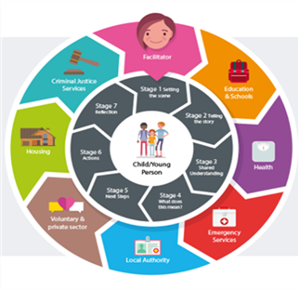

**Safeguarding Bedfordshire Website:**

The new Safeguarding Bedfordshire website launched in July 2023 and has continued to be developed and updated. The website hosts lots of information regarding our safeguarding arrangements, lots of useful information and advice and access to lots of resources, toolkits, case review learning and training.

During 2024/25, 288,404 people visited the website, with 144,326 clicking on the home page. The chart below shows the top 10 pages visited in 2024/25.

|  |  |  |
| --- | --- | --- |
| **Page** | **Number of hits** | **Rating** |
| Safeguarding Bedfordshire Training | 10455 | Most visited page (after homepage) |
| Central Bedfordshire Safeguarding Children Partnership | 9702 | 2nd most visited page |
| Luton Safeguarding Adults Board | 8843 | 3rd most visited page |
| Luton Safeguarding Children Partnership | 8811 | 4th |
| Bedford Borough Safeguarding Children Partnership | 7327 | 5th |
| Report a concern about an adult or a child | 6471 | 6th |
| Upcoming Training | 6382 | 7th |
| Pan Bedfordshire - What does this mean? | 5845 | 8th |
| Welcome to Children & Young People | 4623 | 9th |
| What is Abuse and Neglect? | 4202 | 10th |

A snapshot of 288 training evaluations during quarter 4 highlighted at least 60 evaluations specifically referenced the website, and how useful it is. One evaluation commented….

“The safeguarding Bedfordshire website - phenomenal amount of information and resources!! Easy to navigate and so clear!”

**Annual Reports:**

During 2024-25 The Central Bedfordshire Safeguarding Partnership received the following Annual Reports for review and scrutiny:

* School Attendance
* Children Missing from Education
* Electively Home Educated Children
* Looked After Children
* Domestic Abuse
* Private Fostering
* Exploitation
* Complex Care
* Prevent

**Child Safeguarding Practice Reviews:**

During 2024-25 the Partnership completed two Child Safeguarding Practice Reviews (CSPR’s) that had been initiated the previous year and also carried out two further Rapid Reviews.

**Case 1 – Isabella**

On the 30th of June 2023, Bedfordshire Police contacted Suffolk Constabulary sharing a call that they had received from a friend of Isabella’s mother. The friend had ‘grave concerns’ for Isabella (2 years and 9 months old) following a communication that the friend had received from the mother. Suffolk Constabulary attended a hostel in Ipswich, Suffolk, where the family were staying and discovered Isabella deceased, she was found in her buggy. It is assumed by the findings of the criminal investigation that Isabella had been dead for around three days and had suffered a number of significant non-accidental injuries. Isabella originally lived in Central Bedfordshire before travelling to Norfolk and then Suffolk at the beginning of June.

The table below provides information regarding the recommendations and the Partnership’s response.

|  |  |  |
| --- | --- | --- |
| **Recommendation** | **Action** | **Progress** |
| The Central Bedfordshire Safeguarding Children Partnership (CBSCP) should share this review report with the Norfolk and Suffolk Safeguarding Children Partnerships for them to consider if there is any learning that they would wish to consider actioning within their area. | To share the report with the Norfolk and Suffolk Safeguarding Partnerships | The report has been shared |
| The CBSCP should seek assurance from all agencies that they always include the voice and lived experience of a child in their actions and assessments. This includes children who are toddlers, who are unable to fully communicate verbally. | Request to be sent to all Central Bedfordshire Safeguarding Children Partnership Partners for their Assurances. | Voice of the child assurance audits/reports completed and presented back to the partnership. Reports completed by:   * Central Bedfordshire Council Children’s Services * East London Foundation Trust * Cambridgeshire Community Services * Bedfordshire Police * Bedfordshire Hospitals   Hearing the voice of the child multi-agency training available through Safeguarding Bedfordshire Training service.  Use of the day in the Life Tools promoted to all agencies.  Additional action by Bedfordshire Hospitals:  Paediatricians made aware of the Day in the life too and provided with training, to ensure that children are spoken to alone when presenting to the Trust, and their voice is heard and documented accurately. |
| The CBSCP should ensure that all agencies are reminded of the need to ensure that assessments and interactions with families consider the role, presence and the history of male/female partners living in or associating closely within a household. This could be widened to include all carers to children. | All Agencies to confirm that this learning has been disseminated within their agencies – confirm when and how this was done. | Central Bedfordshire Council, Children’s Services:  Weekly dip-sampling, thematic audits and monthly full case audits have taken place and are showing an improvement in resident and non-resident adults and network information being included within assessments. Promotion of cultural genograms also took place – this work is now Business as Usual (BAU).  Regular programme of learning workshops have also taken place.  East London Foundation Trust:  Audits have been completed on Children and adult records, with a focus on the Think Family Approach to care and the Voice of the Child. Practitioners have been asked to ensure that all family members are recorded on a child's record and to be professionally curious around new partners as well as ensuring that the partner details are also recorded where possible.  In ELFT’s level three training they emphasise the need for good record keeping and practitioners are advised to record all interactions with patients and professionals.  Cambridgeshire Community Services:  Learning forums took place in July and September 2024, and they included a presentation on opening records, how to do this, what policies support this and why it is important. A shortened version was then delivered to locality staff.  CCS opening records policy includes the ‘Think Whole Family’ approach.  Bedfordshire Hospitals:  When a Child/Young Person is booked into A&E they are asked routinely who is accompanying them and Significant Adults information is clearly documented and captured on information sharing form. |
| The CBSCP need to ensure that all professionals are aware of the options that housing have in similar type cases where Domestic Abuse is involved and there are children being impacted by being homeless or in unsuitable accommodation.  Housing departments and Housing societies need to be briefed on this case to understand the risks to children from Domestic Abuse and also of being homeless. The Housing departments and housing societies need to be reminded of their responsibilities to victims of Domestic Abuse. | Work with Central Bedfordshire Housing Team to share this learning. | The learning has been shared locally with housing staff.  The report and learning have been shared with the Ministry of Housing, Communities and Local Government (MHCLG), the Central Bedfordshire Housing Service are in dialogue with MHCLG about this learning can be shared amongst Housing Providers nationally, we expect this to be complete by the end of July.  This learning will also be shared to all professionals through our learning webinar and briefings. |
| The CBSCP need to raise professionals’ awareness, knowledge and understanding of:   1. Ensuring that front-line staff can recognise the signs and symptoms of coercive and controlling behaviour as a key form of domestic abuse.      1. The fact that household domestic abuse is always harmful to children. 2. That all statutory agencies recognise the necessity to complete DASH/DARA’s where a disclosure of domestic abuse has been made, and that this is embedded into procedures and day to day practice. 3. Where children are in a household where domestic abuse is present, that a children’s safeguarding referral should automatically follow alongside any domestic abuse referrals. 4. Statutory professional partners undertake training to identify strategies to disrupt perpetrators of domestic abuse. | Suggested actions:  Rolling program of training for all front-line staff on identifying and risk assessing dynamics of domestic abuse for both family and intimate partner violence and abuse.  Incorporate domestic abuse risk and impact assessment in all case summaries, assessments and plans for children. Clearly identifying where the risk is coming from, and what that specific risk means to the children living in that household. Linking the environmental impact of domestic abuse on child’s development. For example, living in fear or heightened state of anxiety can lead to dysregulation, difficulty in being able to rest or relax at home particularly at night can lead to problems with sleeping.  Training on using the ‘5 questions’ to establish whether DA is present. Embedding in other assessments or direct work, for example as part of GCP2 toolkit. Incorporating DASH risk assessment with specialist domestic abuse services into all assessments where domestic abuse is present.  Link to DASH guidance and form on systems like MOSIAC, to ensure alignment of risk and outcomes with other assessments and/or workflow. Step further would be to consider incorporating requirement for DASH completion where DA is ticked as a risk on systems.  Promoting messaging to all front line and community-based teams that both MARAC and Children’s Safeguarding referrals are required where there are concerns about domestic abuse.  Ensure CBCSB Practitioners Guidance to responding to Domestic Abuse and crib sheet, is embedded into CS practice guidance and team processes.  Bespoke training on engaging with perpetrators could be considered, along with standard off by commissioned perpetrator providers. Highlighting good practice and outcomes across frontline teams.  Identify as a specific training need for all frontline workers through CPD and supervision.  Consider including disruption and intervention strategies specifically for perpetrators in CIN/CP plans for children. | Pan Bedfordshire Training:  Pan Beds multi-agency Domestic Abuse training in place (awareness training and responding to victims/ survivors training) which includes all the listed points. Central Bedfordshire Council also offers a Domestic Abuse Responders training course which is open to Pan Bedfordshire staff and is free to attend.  In November 2023 there was whole Integrated Front Door (IFD) Service training completed by Independent Domestic Violence Advisors (IDVA) service. Including impact of trauma, DA cycles and risk matrix.  Central Bedfordshire Council, Children’s Services:  CBC reviewed their Multi-agency Safeguarding Hub (MASH) Structure in December 2023 which included the consideration of a lead health representative within the Integrated Front Door (IFD) team.    Advanced toolkit and Homicide training took place for the HUB and I&A staff in December 2023.  During December 2023 the whole team meeting focussed on increased agency MASH checks and in January 2024 the Managers Meeting focussed on case direction re MASH checks.  Weekly dip-sampling has taken place since with the Quality Assurance and operational teams to ensure consistency.  The Children’s Services Domestic Abuse training offer was revised and updated and new sessions focusing on Identifying and Responding to risk are now being delivered across Bedfordshire via Workforce development.  Perpetrator provision now mobilised and training offer on engaging with perpetrators for whole IFD team completed in May 2024.  Further bespoke workshops took place in August 2024 and October 2024 for all IFD and partners practitioners and managers.  Further updates from May 2025 update included a rolling programme of scrutiny at the front door, and mandatory workshops in place.  East London Foundation Trust:  Domestic abuse is covered in ELFT’s standard Level three safeguarding training course, are also developing a level three online training update that ELFT practitioners can access as part of their yearly L3 Update training needs – this should be complete by September 2025.  ELFT are also in the process of conducting a QI project over the next few months around making routine enquiries and how we can record this on our electronic system, so that practitioners are asking the question around healthy happy relationships as part of their routine assessments.  Domestic abuse is a subject that comes up regularly within safeguarding supervision and the CBC Domestic Abuse Manager has provided links for ELFT practitioners who are working with young male adult perpetrators of DA against parents so that support can be accessed for them.  DASH and Young persons DASH are also covered in ELFT’s L3 Safeguarding training package and in safeguarding supervision.  Cambridgeshire Community Services:  CCS has a domestic abuse L3 training package which is available to CCS practitioners.  There are quick links on our clinical recording system (SystemOne) to DASH forms – these are also on the intranet and on the safeguarding Padlet.  CCS also has a domestic abuse policy with the inclusion of this information.  Bedfordshire Police:  Safe Lives ‘DA Matters’ training rolled out across the force, including the control room, first responders and investigators. This is an ongoing programme.    Specialist DA investigators in the Emerald team receive a 2-day course before joining the team. This includes the use of DVPNs  There is now a mandated process for considering Coercive and Controlling Behaviour when there is a series of incidents between the same parties. This is covered in supervisor gatekeeping.   * No incident can be closed without acknowledgement that a DARA has been completed. * Op Encompass is now very well established and ensures that schools are made aware of children who have been present at DA incidents so that support can be offered. * The force has a DA Silver meeting and data is produced by analysts which includes high risk offenders. Risk mitigation plans are discussed and agreed.   Bedfordshire Police have confirmed they have good DASH completion rate.  Bedfordshire Hospitals:  Hospital IDVAS work across the trust, whereby domestic abuse questions are routinely asked when concerning factors are identified. Domestic abuse questions are routinely asked at booking, in relation to women who are pregnant.  There is close liaison with Adult Safeguarding colleagues in regard to families presenting whereby domestic abuse concerns are identified, and consideration in view of the think family agenda. |
| The CBSCP should promote the use of:   1. Multi-agency meetings to improve information sharing and assessment of risk. This should include cross border information sharing and assessment of risk decision making. There are no multi-agency meetings evidenced in this case. 2. The use of escalation needs to be highlighted to all professionals and agencies. It could have been used in this case and wasn’t. | Managers from Central Bedfordshire, Norfolk and Suffolk to meet and discuss.  Promotion of the Escalation Process. | Managers from Central Bedfordshire, Norfolk and Suffolk met in July 2024 to discuss how they could better use/improve multiagency meetings such as Strategy Discussions specifically.  In the case of Isabella, information sharing was not necessarily an issue, however they did agree the full history, where there is a child of a vulnerable adult involved, would be shared routinely when requested.    All 3 Local Authorities agreed they should always escalate to their relevant senior managers in their own Local Authority and to those in the other Local Authority, if it is deemed the pathway/outcome decisions are incorrect.  Information regarding the Escalation Process in contained withing our Safeguarding Bedfordshire Standard Working Together Training. We have also developed a stand-alone webinar which will be delivered once some trainers have been identified.  Information regarding the Escalation Process is available on our Safeguarding Bedfordshire website  <https://safeguardingbedfordshire.org.uk/p/report-a-concern/escalating-concerns>  The link to the process has also been included within our Safeguarding Bedfordshire Newsletters. |
| The CBSCP should advise professionals that a diagnosis of ADHD is a disability characteristic, also the pathways that should be taken and by whom for those going through a formal diagnosis of ADHD. They should also highlight what reasonable adjustments should be made for the clients. | Information to be shared within CBSCP partner agencies. | CBSCP Partners have been asked to share this information regarding ADHD and reasonable adjustments within their agencies.  Links to NHS information regarding ADHD has also been added to the Safeguarding Bedfordshire website and shared within our Safeguarding Bedfordshire Newsletters. |
| The CBSCP should initiate the discussions for the development of regional or national cross-border guidance which includes the opportunity for Children’s Services to request welfare visits, and for a Section 47 to be initiated in the area the child is now resident. | Recommendation to be discussed at the Eastern Region Meetings | The Eastern Region had an existing protocol that covered the transfer of children across local authority boundaries for children on Child Protection Plans, this has now been updated to include Children in Need.  A Pan Bedfordshire Protocol was also agreed include responsibilities under s17 CIN as well as s47 CP enquiries.  In relation to welfare visits we are aware that the National Panel has agreed in another CSPR that there is national policy recommendation to be clear about the responsibility of initiating visits and S47s. This action cannot be completed until that CSPR report is published. |

**Case 2 – Baby Harry**

In February 2024 a six-month-old child, who for the purpose of our CSPR was known as Baby Harry, tragically died. Abuse and neglect were suspected, resulting in a Police investigation.

|  |  |  |
| --- | --- | --- |
| **Recommendation** | **Action** | **Progress** |
| Individual agencies that have contributed to this review have each, where necessary, submitted their own learning and associated action plan as a result of recommendations they have identified themselves. | IMR Actions to be monitored | Action Plan developed and being monitored via the CBSCP Case Review Group |
| In respect of pre-birth assessment activity:   1. The Partnership should continue to build on the recommendation (recommendation 5) recently made in the Daniel & Sophie CSPR (March 2024) about promoting awareness about the Pan Bedfordshire Procedure and Guidance in relation to Pre-Birth Planning and Assessments. 2. The Pan Bedfordshire Procedure and Guidance in relation to Pre-Birth Planning and Assessments should be strengthened to include: 3. Greater reference to contingency planning and different scenarios where this may be applicable, 4. The need to share with relevant multi-agency partners the completed Pre-Birth Assessment report to aid multi-agency discussion, scrutiny and decision making, 5. The contributions to multi-agency assessment, information sharing and decision making of the Pre-Birth Tracking Meeting. 6. Guidance (including procedural aspects that refer to continued responsibilities to safeguard and promote the welfare of children) regarding follow-up by the Children's Centres where parents of newborns or children under two years of age, have been offered opportunities to attend for support, and these have not been followed through particularly when support is not accessed. | Continued promotion/awareness of the Pre-Birth Protocol  Review of the Pre-Birth Protocol | The Pre-Birth Protocol and Assessments are promoted and signposted to within the Safeguarding Bedfordshire Training. They were also referenced within our CSPR webinars earlier in the year (they will continue to be referred to in future webinars as they are developed). Pre-birth assessment info shared in Jan 2025 and May 2025 Safeguarding Befordfordshire newsletter**.**  Pan Bedfordshire Pre-Birth Assessment Guidance has been reviewed and updated.  Additional Updates:  ELFT:  The learning from Daniel and Sophie around Pre Birth Assessment was shared within L3 training and in Safeguarding supervision.  The allocated Peri-natal Service professional is normally invited to be part of the Pre-Birth Assessment process and will take part in any safeguarding or relevant meetings if the patient is open to their service.  Children’s Social Care:  Two audits have been completed of pre-births, improvements seen in curiosity and analysis. All children known to CSC have safety plans. Weekly single agency and multiagency scrutiny at the front door is now Business as usual. Sharpened the TOR for the pre-birth tracking meeting, attendance being monitored and chaired independently by Quality Assurance Team. Rolling programme of mandatory workshops and scrutiny activity is in the annual plan and Business as usual. Process in place for all CSC 0-19 services to re-refer families back in if they do not go on to access services. |
| A multi-agency protocol should be developed that supports the re-referral back to an appropriate agency, when parents who originally consented to seeking and engaging with additional support, fail to do so. | Development of a multi-agency protocol | This additional multi-agency guidance has been developed and will be included within the Pan Bedfordshire processes.  Additional Updates:  Cambridgeshire Community Services:  Messages shared with practitioners that if an assessment has recommended the family needs to engage with a health service and this does not happen, then this information should be shared back to the LA so they can consider the information as part of their previous assessment.  ELFT:  If a patient is open to the Perinatal team and does not engage with the service, this will be shared with the referrer as part of the Non –Engagement policy the team have in place. Any safeguarding concerns will be shared with children’s social care. |
| The Partnership should raise awareness and understanding about the Under 20’s Support Pathway with key agencies and professionals. | Review and awareness of Under 20’s pathway | Following the review the under 20’s pathway and processes have been reviewed between CBC Public Health, CBC Children’s Services, Bedfordshire Hospitals and Cambridgeshire Community Services – the pathway and process have been updated together, and all agencies are now clear on the pathway and processes. The pathway has also been uploaded to both the Bedfordshire Hospital intranet sites.  An audit as part of this CSPR showed that the pathway wasn’t being used in one of the Hospitals – suggest a follow up audit takes place in a few months’ time to confirm this action has had an impact. |
| In respect of Findings of Fact being used to safeguard all children:   1. The Child Safeguarding Practice Review Panel have highlighted in the response letter to the Partnership that they have regular contact with the Ministry of Justice and the President of the Family Division. Following discussion with the Child Safeguarding Practice Review Panel about this review and its findings, the Partnership should request the Child Safeguarding Practice Review Panel formally take this matter forward with both the Secretary of State for the Ministry of Justice and the President of the Family Division. 2. The Partnership should also directly contact the Secretary of State for the Ministry of Justice and the President of the Family Division, advising them of the findings and recommendations of this review, and seek a response. 3. The following recommendations are offered as a potential remedy to the current situation:  * Practice Direction 12G which supplements the Family Procedure Rules Part 12, notably the entry which refers to communication of information with a Police Officer for the purpose of a criminal investigation (third from last): this should be amended to reference information being shared with ‘Chief Officers of Police’, as defined under the Police Act 1996, and with the purpose of information being communicated ‘for the purpose of a criminal investigation’ but also extended to include ‘and for the purposes of sharing information to promote public safety’. Chief Officers of Police may then delegate the responsibility of this action to their Disclosure Units. * Information from Findings of Fact made in Family Proceedings should be added to the Police National Computer (to become the National Law Enforcement Data Service) to allow any Police authority the ability to access relevant information on the same basis as the current Domestic Violence Disclosure Scheme (Clare’s Law) and the Child Sex Offender Disclosure Scheme (Sarah’s Law) operates. Information from Findings of Fact should then be shared using the same principle of ‘Right to ask – Right to know’. This principle allows Police to make disclosures using their own initiative about safety to other members of the public, which would include children. * A formal response to the above recommendations should be shared back to the Partnership, by those it has been shared with i.e. the Child Safeguarding Practice Review Panel, the Secretary of State for the Ministry of Justice, and the President of the Family Division. If the decision is taken not to pursue the concept of sharing of Findings of Fact with the Police from Family Courts or not to strengthen Practice Direction 12G, the rationale should be provided to the Partnership to allow learning; this should be published alongside this report when it is also published. This will allow greater scrutiny and challenge given the likelihood of such a scenario, as outlined in this review, occurring again. | Liaise with National Panel | Meeting held with representatives from the National Safeguarding Panel and letters sent to the President of the Family Division and Secretary of State.  Response:  The Government recognises the importance of ensuring that victims and survivors can obtain protective orders when this is the most appropriate measure, and that the police stand ready to monitor and enforce these orders. We’re considering how we can strengthen the protective order regime, including our manifesto commitment to strengthen how Stalking Protection Orders are used. We are also piloting the new Domestic Abuse Protection Orders.  However, we acknowledge there is currently a gap in the way that family courts share information about Non-Molestation Orders with the police. Together with the Home Office, the National  Police Chiefs’ Council and His Majesty’s Courts and Tribunals Service, we have established a working group to consider how notification of orders from the courts to the police can be improved. We also have an ongoing workstream on disclosure with the Family Procedure Rule Committee, focusing on Practice Directions 12B (Child Arrangements Programme) and 12J (Child Arrangements and Contact Orders: Domestic Abuse and Harm), which the Committee will  consider over the next twelve months. I will ask my officials to consider whether this workstream could be widened to incorporate the suggestions made in the Child Safeguarding Practice Review.  Please note that all of the Committee’s work is triaged, meaning that an item’s position on the workplan may change. |

**Case 3 – Child A**

A Rapid Review was completed for Case number 3 which related to two children who were aged 10 and 12 years old and living with their mother and stepfather. The children were vulnerable with the family being known to services for several years. One of the children was sexually abused by their Stepfather who was already known to be sex offender.

|  |  |  |
| --- | --- | --- |
| **Recommendation** | **Action** | **Progress** |
| The family were known to services since 2013 due to neglect concerns, this issue has been on-going but at no point has the Graded Care Profile been considered or completed.  This is an on-going issue within Central Bedfordshire that we are currently trying to address through awareness raising, more guidance, training and seeking further commitment from our partners, which will continue. | Continue to raise awareness of the GCP2 and encourage it’s use through the Pan Beds Neglect Group | The use of Graded Care Profile was promoted at the Pan Bedfordshire Neglect Conference and continues to be promoted within our training offer and webinars and at other forums such as the DSL forums. Additional GCP2 Trainers have been trained to ensure that GCP2 training continues to be offered as much as possible. Guidance tools and flowcharts have been produced and are available on the Safeguarding Bedfordshire website and the use of the GCP2 is an on-going standing item discussion at the Pan Beds Neglect Sub-group. The number of GCP2’s completed broken down by agencies continues to be monitored through the Pan Bedfordshire Neglect Group and the Central Bedfordshire Performance Group.  Additional updates:  Cambridgeshire Community Services – The GCP tab on SystmOne has now been updated to a neglect tab to help support signposting practitioners to use the GCP2 as a neglect risk assessment as well as other tools e.g. the neglect screening tool, obesity screening tool and clutter score.  Children’s Social Care:  Several Audits were completed, although the initial audit in July 2024 indicated numbers completed were low and the effectiveness was unclear, a follow up multi-agency audit in February 2025 showed practice had improved.  Training in relation to neglect is available through Safeguarding Bedfordshire. |
| Child Protection Medicals – Although there were concerns around neglect and also concerns around K having UTI’s, incontinence and bed wetting, neither neglect nor sexual child protection medicals were considered or took place. Awareness around the use of child protection medicals will continue. | Continue to raise awareness of the use of Child Protection Medicals | This learning was shared amongst partners including via a 7-minute briefing. Information to provide child protection medicals is also included within our safeguarding training packages. Learning was also shared in the Safeguarding Bedfordshire Newsletter.  Additional updates:  Cambridgeshire Community Services:  CCS has a L3 Neglect training package and within this package neglect medicals are discussed as a tool available to support identification of neglect and of care planning.  Children’s Social Care:  In September 2024 a reflective session took place with GPs to consider the threshold, intervention and appropriateness for CP medicals. |
| Engagement of Fathers – Both the children’s biological fathers had contact with them, but the multi-agency professionals involved didn’t consider who was in their protective networks and the fathers were included less and less as time went on. | Learning to be shared widely amongst partner agencies and professionals | This learning was shared amongst partners including via a 7-minute briefing. Information regarding the engagement of fathers and wider networks is also included within our safeguarding training packages. Learning was also shared in the Safeguarding Bedfordshire Newsletter.  Additional updates:  Children’s Social Care:  Family networking and think family approach is Business as usual along with the promotion to complete cultural genograms for all children to further understand their networks. There are also regular mandatory workshops.  Cambridgeshire Community Services:  Learning forums took place in July and September 2024, and they included a presentation on opening records, how to do this, what policies support this and why it is important. A shortened version was then delivered to locality staff.  CCS opening records policy includes the ‘Think Whole Family’ approach. |
| Over reliance on written agreements– There was an over reliance on written agreements and a naivety that mother (who had openly said she believed her partner) would adhere to them and keep her children safe, particularly in relation to the second written agreement when the first agreement had been broken. It was agreed that written agreements should no longer be used, but we need to develop staff to be able to draft strong safety plans. | Stop the use of Written Agreements in Central Bedfordshire.  Development of our CSA work within Central Bedfordshire, via the CSA NSPCC Snapshot:  Central Bedfordshire are currently part of an NSPCC Snapshot Project in relation to Child Sexual Abuse with the aim of helping us to develop the following locally:   * Local Child Sexual Abuse Strategy * Local Pathways * Awareness and Knowledge * Training and Development * Holistic Multi-agency Responses * Availability and Quality of Service Provision | Following the completion of the CSA Snapshot, a Pan Bedfordshire CSA Strategy and Action Plan has been developed to implement the recommendations. A CSA Steering Group is overseeing the implementation of the action plan.  Additional updates:  Children’s social Care:  DCS direction for CBC not to use written agreements.  Focussed workshops undertaken around sexual abuse and its impact, non-offending adults, safety and contingency planning rolled out to all practitioners, managers, Heads of Service, and ADs in August and October 2024.  Further audit activity has allowed the service to feel confident that safety plans are completed for all children and families and uploaded on to their records. This practice is now business as usual – development workshops have acted as a reminder and support staff with the quality.  Cambridgeshire Community Services:  CCS currently has a sexual abuse L3 training package where safety planning is discussed. |
| Information Sharing – there are times when information was not shared appropriately between agencies, for example it was CAFCASS that initially notified Children’s Services of Stepfather’s conviction and not the Police. | Learning to be shared widely amongst partner agencies and professionals | This learning was shared amongst partners including via a 7-minute briefing. Information regarding information sharing is included within our safeguarding training packages. Learning was also shared in the Safeguarding Bedfordshire Newsletter.  Additional Updates:  Cambridge Community Services:  The importance of timely referrals is highlighted to all CCS practitioners as part of their foundation training as new starters and reiterated at their yearly L3 updates. This message is also shared in safeguarding supervision and links to make referrals are accessibly on our clinical recording system (SystmOne) via safeguarding quick links, the intranet and the safeguarding padlet.  In addition, a referrals audit was undertaken by CCS, which showed that in 100% of the cases sampled it was found that referrals were made in a timely manner.  Children’s Social Care:  Assurance activity including weekly dip-sampling, thematics and full case audits undertaken to ensure information is shared in a timely manner. Escalation processes are in place where this has not been the case. A reflective session was held with all managers, Heads of Service and ADs in July and October 2024.  Bedfordshire Hospitals:  In relation to information sharing, a development of a safeguarding care plan is due to be aligned across Bedfordshire Hospitals (Luton and Bedford Site) to ensure for timely and efficient information sharing. |
| Understanding of risks between agencies– In this case other partners did not understand the risk posed by a ‘Medium Risk’ as assessed by Probation, neither did they necessarily understand the gradings of the sexual offences/images. This is an area of development to help assessing risk in the future and some future multi-agency training and workshops are needed around this topic. | Risk Assessment and Thresholds Webinar to be developed | The Central Bedfordshire Safeguarding Children Partnership webinar ‘Risk Assessments &  Thresholds was held on the 27th February 2025 and aimed to raise practitioner awareness of the risk assessment and threshold guidance used by different  agencies, and to consider how we work with the different standards of proof and ensure the child/ young person at  the centre of our practice. The session focused on concerns around Child Sexual Abuse.  Presentations were delivered by Cambridgeshire Community Services, HMP Probation Service, Central Bedfordshire  Council Children’s Services, Bedfordshire Police ICAIT and Offender Management Teams. This webinar highlighted  each agencies approach to risk management, and how information sharing was key to accurate and up to date  assessments.  We received 77 bookings via Eventbrite, with 70 practitioners (82%) joining the session. |
| Disguised compliance – There were incidents and times of disguised compliance from mother, therefore further work with practitioners around recognising and challenging disguised compliance is needed. | Learning to be shared with practitioners and highlighted in training. | This learning was shared amongst partners including via a 7-minute briefing. Information regarding disguised compliance is included within our safeguarding training packages. Learning was also shared in the Safeguarding Bedfordshire Newsletter.  Additional updates:  Children’s Social Care – programme of mandatory workshops in place. |
| Over reliance on self-reporting– Within this case there was an over reliance on the self-reporting from Stepfather around his addiction and risk levels towards the children, and too much emphasis placed on the fact he said he had self-referred himself to the GP for help. | Learning to be shared with practitioners | This learning was shared amongst partners including via a 7-minute briefing. Information regarding professional curiosity is included within our safeguarding training packages. Learning was also shared in the Safeguarding Bedfordshire Newsletter.  Additional updates:  Children’s Social Care – programme of mandatory workshops in place. |

**Case 4 – Family B**

A Rapid Review was completed for Family B, whose children were being Electively Home Educated but were taken into protective care due to neglect.

|  |  |
| --- | --- |
| **Learning Points** | **Actions Taken** |
| Children and Families | |
| 1. Improving the process of how and when information is passed from Councillors to the Local Authority. | In addition to the formal process of referring into the Integrated Front Door, Central Bedfordshire Council (CBC) has (and is):   1. Implemented an internal process for Elected Members to alert senior managers of any information or concerns they may have. 2. Undertaking Elected Members dip-sampling sessions in December 2024 to ensure they understand safeguarding and referral mechanisms. A follow-up session will be undertaken February 2025. |
| 1. Progressing the practice learning in respect of:  * The child’s lived experiences * Acting on children where the decision to home educate raises concerns * Professional curiosity around changing presentations and disguised compliance * Exploring cultural identity * The role of Fathers and parental responsibility | **CBC Children and Families Service:**  CBC Children and Families Service has undertaken, progressed and tested the learning as follows:   1. All Managers workshops undertaken in July 2024, focussing on expediating referral information and the impact of children missing education (including Elected Home Educated children in ‘out of character’ circumstances). 2. Bespoke/thematic workshops August 2024, and October 2024 focussing on professional curiosity; analysis and assessment of known and unknown risks including cultural identity, the voice of the child, parental responsibility and the role of Fathers, safety and contingency planning and professional escalation. 3. Single and multiagency reflective sessions held in September 2024 to understand roles and responsibilities and impact. 4. Reflective session held with Senior Leadership Team in September, and October 2024 to understand the children’s lived experiences and the impact. 5. Reflections and key learning shared at the Director of Children’s Services (DCS) Roadshow November 2024. 6. Reflective session held with the Extended Leadership Team (ELT) revisiting the learning November 2024.   **Independent Quality Assurance activity:**   1. Weekly Integrated Front Door cross service and multiagency dip-sampling to test threshold decisions. 2. Quality assurance of the ‘Stop, Pause, Think, Do Review’ process testing professional curiosity, consent (or lack of), gathering relevant information, analysis and decision making. 3. Holistic monthly manager audits undertaken to evaluate all domains of the child’s lived experience. 4. Schools Designated Safeguarding Leads (DSL) dip-sampling and reflective workshop; focussing on roles and responsibilities, thresholds and threshold decisions, what makes an analytical referral and professional escalation processes - November 2024. 5. Dissemination of escalation policy and processes to all DSLs.   **CBC Access and Inclusion Service:**  In relation to EHE and CME processes,  The EHE Team will:   * Contact the Integrated Front Door (IFD) by email with a copy of the referral if there has been a contact and referral in the last 3 months. * Contact previous LA if parent informs EHE team they are EHE and moved into area and request any relevant information. * Update EHE review period document * CME/EHE will create some video training by the end of April 2025 * The majority of CME is unplanned, although in cases like this were the EHE appears unsatisfactory it is a planned opening of CME with a School attendance order (SAO), we have significant numbers of children with 3 + SAO breeches. We hold a CMEcase review panel every 6 weeks forchildren over 12 weeks CME. We intend to invite an Integrated Front Door/Hub member to attend these. * When we have an EHE referral from out of county, unless we have clear EHE information and the parental letter requesting EHE, we will open as CME for enquiries.   Things that would help the EHE/CME team:   * For every contact to the IFD/hub, the referrer is asked for education information and if provided as a school the name of the school recorded. * Consideration of educational neglect as part of safeguarding * The IFD/hub to check tribal for every referral if the child is EHE/CME and prompt a case discussion with the CME/EHE team.   In relation to the lived experiences of the young people in this case, the records stated the Elective Home Education team were informed; however, they advised that it was unlikely they would be home visiting, which was a missed opportunity to understand the children’s lived experiences.  The EHE Team don’t have a right to visit families at home or meet with the children. As this mother made clear she would engage although via email and we had written EHE information initially education appeared suitable.  The EHE team always tell schools/professionals that we can’t safeguard/visit/see children/complete welfare checks because of the powers given to us under the education act. We advise them to refer to social care if they require these actions.  We will be tightening the review period document which could lead to more frequent contacts although these may be brief and by letter.  In relation to the roles of fathers and parental responsibility, the Access and Referral Team will continue to contact both parents.  **Cambridgeshire Community Services:**  The lived experience of the child is a focus of much of the partnerships work with ‘day in the life’ tools being used by this agency and others. Cambridgeshire Community Services also has a ‘think family’ approach and this is ongoing work within community health services. |
| **CAFCASS** | |
| 1. Identifying and acting on risk to children as soon as they arise: Connecting key information that increases risks to children and referring to the Local Authority if professionals (the Family Court Advisor in this case) cannot contact relevant adults (Mother in this case). | CAFCASS have a policy and expectation that where there is an identified risk, a referral should be made to the relevant local authority Children’s Services. On reflection following the rapid review, we feel this was a case that should have been considered for a referral. Staff have been reminded this policy/expectation. |
| **Police** | |
| 1. Supporting Children and Families in welfare checks as soon as significant harm is suspected | All of the staff and officers (and their line management) involved in the initial decision for police not to attend when this was first reported to police on 22/07/24 have been made aware that the risks as described by CSC ought to have resulted in attendance at that point. They have been made aware of the outcome the following day to help them better understand the risk to the children. In addition, a process will be introduced where CSC should request an urgent strategy meeting with the Police Public Protection Unit Hub and seek agreement for a joint s47 and joint visit. |
| **Schools** | |
| 1. Increase the use of the escalation procedure 2. Referring allegations of physical abuse as soon as they arise | 1. Feedback from the Rapid Review has been shared with the Hertfordshire Safeguarding Children Board and Hertfordshire Child Protection School Liaison Officer Team, for them to share this learning with the relevant schools. 2. Central Bedfordshire Council (CBC) undertook a Schools Designated Safeguarding Leads (DSL) dip-sampling and reflective workshop; focussing on roles and responsibilities, thresholds and threshold decisions, what makes an analytical referral and professional escalation processes - November 2024. Dissemination of escalation policy and processes to all CBC DSLs. |

**Training:**

The Partnership Training Report is contained in **Appendix A**.

**Performance:**

Throughout the year the CBSCP Performance group have monitored and scrutinised the partnership dashboard on a quarterly basis, below are some highlights of some of our key performance indicators:

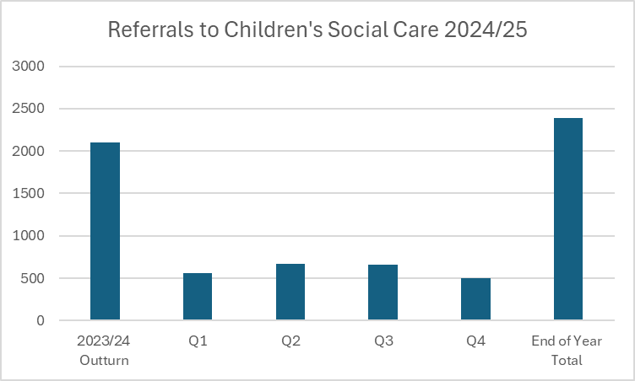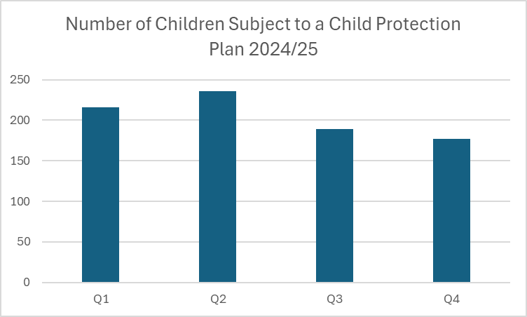

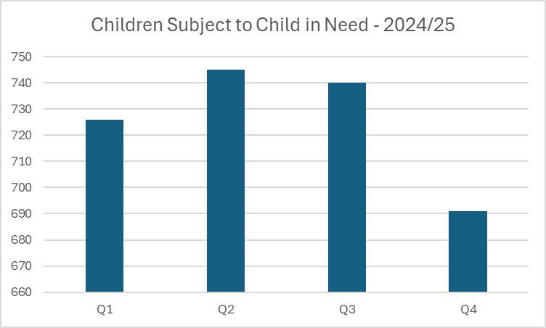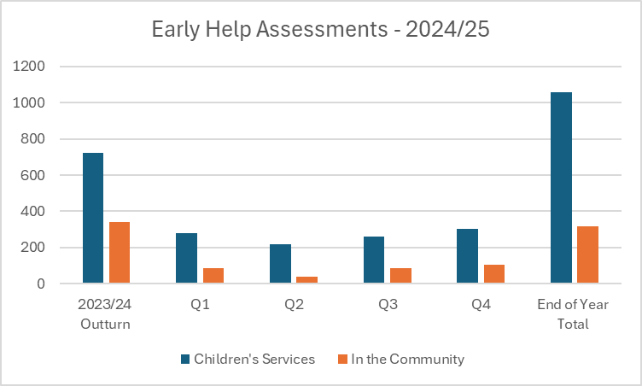

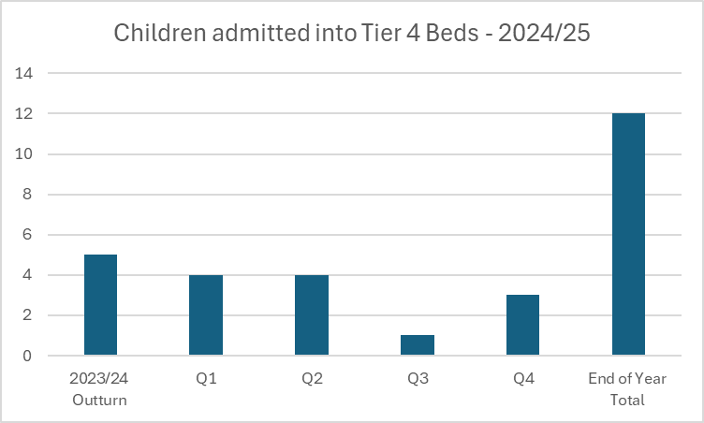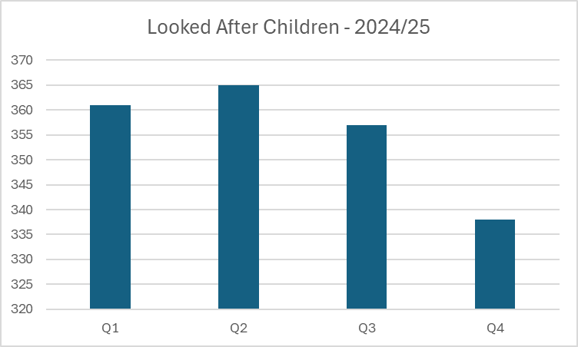

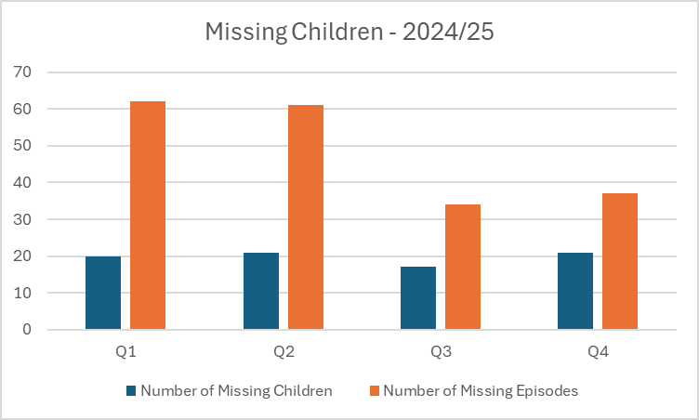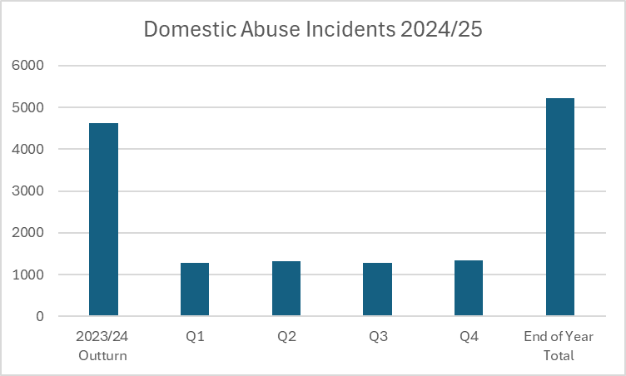

A Pan Bedfordshire Data Analyst has recently been recruited; the embedding of this role will take place during 2024/2

**Funding Contributions and Spend:**

Current funding arrangements (Per year), including the costs of both the Business and Training Units.

**Annual Funding Contributions:**

|  |  |  |  |  |
| --- | --- | --- | --- | --- |
| **Partner** | **Total Contribution** |  | **Business Unit/Training Split** | **Overall Percentage of Contribution** |
| Central Bedfordshire Council | £133,041.45 |  | £116,982.33 – Business Unit | 63% |
|  | £16,059.12 – Training Unit |
| BLMK ICB | £54,829.84 |  | £44,905.64 – Business Unit | 26% |
|  | £9,924.20 – Training Unit |
| Bedfordshire Police | £19,991.61 |  | £16,373.13 – Business Unit | 10% |
|  | £3,618.48 – Training Unit |
| Probation | £2,200 |  | £1,801.80 – Business Unit | 1% |
|  | £398.20 – Training Unit |
| **Total Budgets** | **£210,062.90** |  | **Business Unit - £180,062.90**  **Training Unit - £30,000.00\*** |  |

**Business Unit Spend 2024/25:**

Annual contributions: £180,062.90

Previous carried forward: £ 79,390.23

2024/25 Spend: £175,750.18

**Breakdown 2024/25:**

|  |  |
| --- | --- |
| **Expenditure** | **Amount** |
| Staffing | £133,451.90 |
| Independent Chair/Scrutineer | £21,000 |
| Car Mileage (Independent Scrutineer) | £719.37 |
| Training | £275.00 |
| Website development | £4,066.74 |
| Catering Supplies | £35.75 |
| Subscription | £815.00 |
| CSPR’s costs | £8,674.30 |
| Additional CDOP Costs | £6,712.12 |
| **Total Spend** | **£175,750.18** |

£30,000 is also spent by the CBSCP on multi-agency training.

A further £7,000 is provided by CBC towards the contribution costs of CDOP.

**Summary and Areas for Development/Next year’s focus:**

The CBSCP has worked well throughout 2024/25 and has a strong cohesive partnership, where partners come together and progress partnership work well, but are also able to debate and challenge each other in a positive way when needed.

In particular throughout the year the Partnership has carried out a large amount of quality assurance and audit work along with several case reviews and Rapid Reviews with all recommendations being acted upon. The partnership has worked hard in the areas of neglect to raise awareness of neglect and increase the use of tools such as the graded care profile and the day in the life tools, however work by partners to really embed the use of these are still needed. The Partnership has a strong multi-agency training offer and development of learning webinars following our case reviews has been a very positive addition this year. Our voice of the child work continues to grow each year, and we are keen to further strengthen this year on year.

The Partnerships work around Child Sexual Abuse is an area which has begun to be developed during 2024/25 and will be a key area to continue to progress over the next year. Our Partnership work around exploitation is an area which has been identified as a key area for us to continue developing and strengthening throughout the new year ahead.

Moving forward throughout the next year the Partnership is also keen to consider ways in which we can offer partnership development opportunities and also really develop the ways in which we measure the success and impact of the work we do, to ensure the work of the Partnership is making a difference to the children and young people within Central Bedfordshire.

**Priorities for 2025/26:**

* Neglect
* Child Sexual Abuse
* Exploitation
* Under 5’s and Non-Accidental Injuries
* Voice of the Child

 Other key areas for partnership focus:

* Embedding learning
* Partnership Development Opportunities
* Strengthening how we measure impact – ensure our work from Case Reviews have had an impact
* Developing stronger links with SEND